**Professional Education Overview & Finding Related Courses: A Compendium of Content Material**

Staying up-to-date in the ever-evolving field of dentistry is crucial for dental professionals to provide optimal care to their patients. Here's a diverse collection of content material to cater to your educational needs:

**1. Focus on a specific dental specialty:**

**Periodontology:**

Explore the latest research on periodontal disease prevention, minimally invasive treatments, and regenerative approaches for gum tissue regeneration.

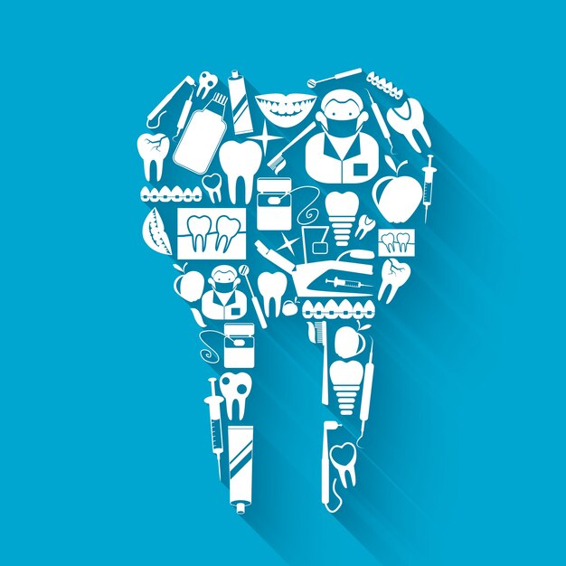

**External Links:**

American Academy of Periodontology:

<https://www.perio.org/>

European Federation of Periodontology:

<https://www.efp.org/europerio/home/>

Journal of Periodontology:

<https://aap.onlinelibrary.wiley.com/>

**Orthodontics:**

Dive into advancements in clear aligners, accelerated orthodontic techniques, and the role of digital technology in treatment planning.

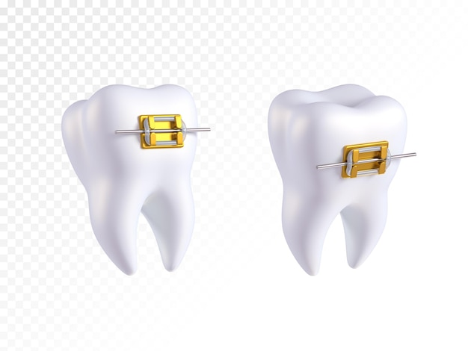

External Links:

American Association of Orthodontists:

<https://aaoinfo.org/>

American Journal of Orthodontics & Dentofacial Orthopedics:

<https://www.ajodo.org/>

**Oral and Maxillofacial Surgery:**

Learn about minimally invasive surgical techniques, facial trauma reconstruction, and the use of 3D printing in surgical applications.

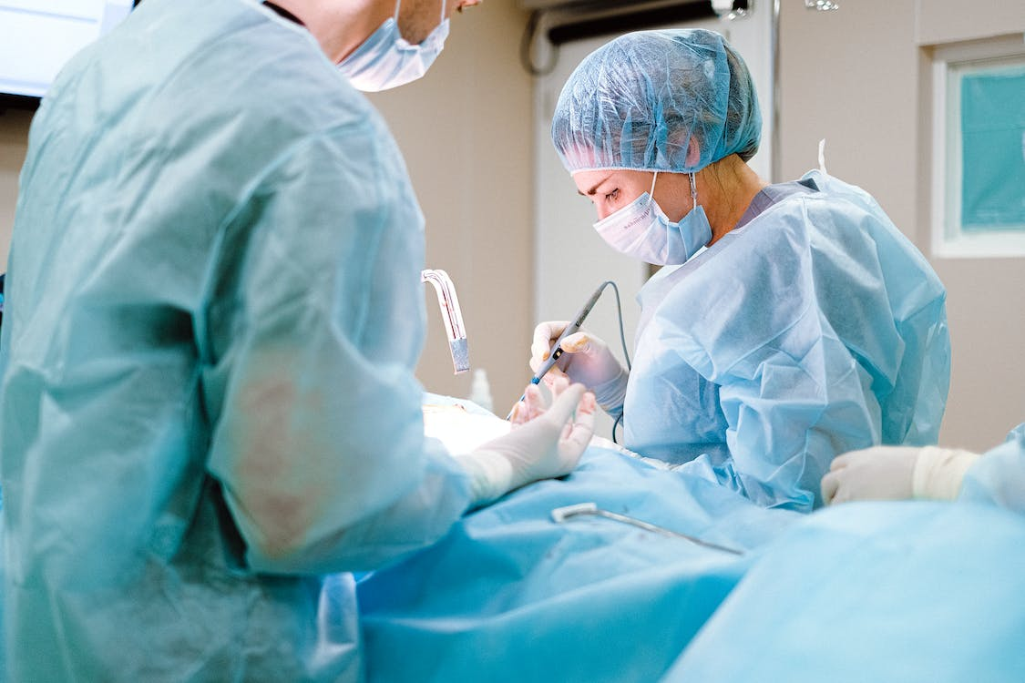

External Links:

American Association of Oral and Maxillofacial Surgeons:

<https://www.aaoms.org/>

European Association for Cranio-Maxillo-Facial Surgery:

<https://www.eacmfs.org/>

Journal of Oral and Maxillofacial Surgery:

<https://jada.ada.org/>

**2. Deep dive into a trending topic:**

**AI in Dentistry:**

Explore how AI is transforming diagnosis, treatment planning, and even robotic-assisted surgery in the dental field.

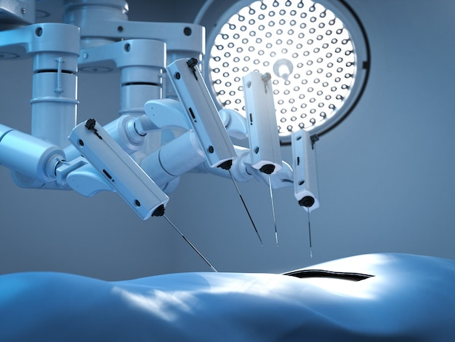

External Links:

"The Future of Dentistry: How AI is Changing the Game": <https://medium.com/@muskandentalai/patients-showed-a-positive-attitude-towards-the-use-of-ai-in-dentistry-83f5ba6f4f7d>

"Artificial Intelligence in Dentistry: A Review":

<https://pubmed.ncbi.nlm.nih.gov/37461385/>

**Dental Sleep Medicine:**

Learn about the link between sleep apnea and oral health, diagnosis techniques, and treatment options like oral appliance therapy.

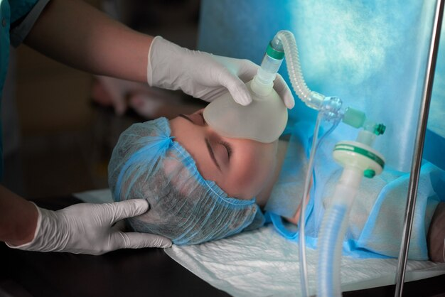

External Links:

Academy of Dental Sleep Medicine:

<https://www.aadsm.org/>

American Academy of Sleep Medicine:

<https://aasm.org/>

Journal of Clinical Sleep Medicine:

<https://jcsm.aasm.org/journal/jcsm>

**Sustainability in Dentistry:**

Discover eco-friendly materials, waste reduction practices, and energy-efficient technologies for a greener dental practice.

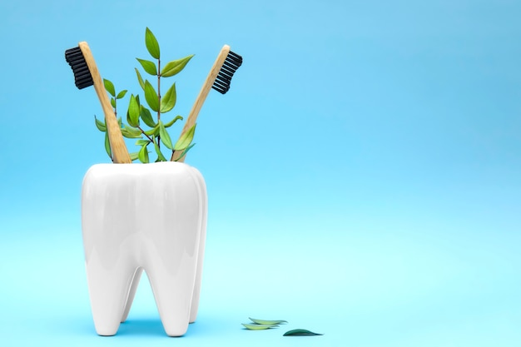

External Links:

Greener Dentistry:

<https://greenerdentistry.global/>

"Sustainability in Dentistry: Strategies for a Greener Practice":

<https://pubmed.ncbi.nlm.nih.gov/28642517/>

**3. Case studies and clinical scenarios:**

Analyze real-life patient cases with challenging diagnoses or treatment complexities. Discuss different approaches, decision-making processes, and potential outcomes.

Role-play common patient interactions, focusing on effective communication, addressing patient anxieties, and building trust.

Participate in online forums or discussion groups to share and learn from the experiences of other dental professionals.



External Links:

Dental Town:

<https://www.dentaltown.com/>

Dentistry Today:

<https://www.dentistrytoday.com/>

Journal of the American Dental Association (JADA) Case Reports:

<https://jada.ada.org/>

**4. Creative and engaging formats:**

Explore interactive learning platforms like virtual reality simulations or gamified dental training modules.

Attend live workshops or hands-on training sessions to gain practical skills and experience new technologies.

Listen to podcasts or watch video lectures from renowned dental experts to stay updated on the latest advancements.

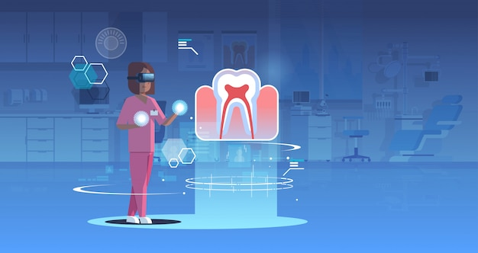

External Links:

Dental VR:

<https://www.dentaverse.io/>

Dentistry IQ:

<https://www.dentistryiq.com/>

The Dental Podcast:

<https://dentwoo.com/>

**5. Beyond clinical skills:**

Enhance your business acumen with courses on practice management, marketing strategies, and financial planning for dental professionals.

Develop leadership skills through workshops on communication, team building, and conflict resolution.

Explore the ethical considerations and legal aspects of dentistry to ensure responsible and compliant practice.

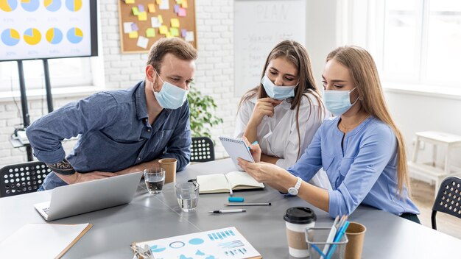 External Links:

ADA Center for Professional Development:

<https://www.ada.org/en/education/continuing-education>

Dental Practice Management Association:

<https://www.dentalmanagers.com/about/dpln/>

Dental Ethics Journal:

<https://pubmed.ncbi.nlm.nih.gov/37831193>

Remember, the key is to choose content that aligns with your interests, learning style, and career goals. Don't hesitate to explore diverse resources and formats to find what keeps you engaged and motivated in your dental professional education journey.

I hope these alternative ideas inspire you to further explore the fascinating world of dentistry!

**Bonus Resources:**

American Dental Association (ADA):

<https://www.ada.org/>

International Journal of Oral Science:

<https://www.jstage.jst.go.jp/browse/ijoms/-char/ja>

Dental Tribune International:

<https://www.facebook.com/DentalTribuneInt/>

Oral B Professional Education Overview:

<https://www.oralbprofessional.co.uk/s/professional-education-overview>

Dental Town

<https://www.dentaltown.com/onlinece?gclid=CjwKCAiApuCrBhAuEiwA8VJ6JiWx6uPZrJCJXKi1IKEWkj3VdV56KKa8xd2SiuGcz-ifq-tlNKY1bRoCTYQQAvD_BwE>

Coursera

<https://www.coursera.org/courses?query=dental>

Class Central

<https://www.classcentral.com/subject/dentistry>

Study Portals Short Courses

<https://www.shortcoursesportal.com/search/course/dentistry>

Penn Dental Medicine

<https://www.dental.upenn.edu/news-events/2023/01/20/penn-dental-medicine-launches-new-coursera-course-frontiers-in-dentistry/>